AWS
Cloud Computing:
- Cloud computing is to access the computing resource via the internet.
- Hosted by provides like Aws, Azure and Gcp.
- Pay-as-you-go Pricing Model.
- No upfront costs or maintance needed.
Features:
On-demand self-service is a feature of cloud computing that allows users to automatically provision and manage computing resources (like servers, storage, and applications)
Broad network access is a key characteristic of cloud computing, allowing services to be accessed over the internet from a wide range of devices, such as smartphones, laptops, and tablets.
Resource pooling in cloud computing refers to the provider's ability to serve multiple customers using a shared pool of computing resources, such as storage, processing power, and memory.
Rapid elasticity is a cloud computing feature that allows resources to be automatically scaled up or down based on demand.
Different Service Models:
- Infrastructure as a Service is a cloud computing model that provides virtualized computing resources over the internet, including servers, storage, and networking.
- It allows users to rent infrastructure on a pay-as-you-go basis to maintain physical hardware.
- Platform as a Service is a cloud computing model that provides a platform allowing developers to build, deploy, and manage applications without managing the underlying infrastructure.
- Software as a Service is a cloud computing model where software applications are delivered over the internet on a subscription basis. Users can access and use the software through a web browser without needing to install or maintain it on their own devices.
Cloud Computing Deployment Models:
- A public cloud is a cloud computing environment where services and infrastructure are owned and operated by a third-party provider, such as AWS, Microsoft Azure, or Google Cloud. Over the internet on a pay-per-use basis.
- A private cloud is a cloud computing environment that is used exclusively by one organization.
- A hybrid cloud is a computing environment that combines both private and public cloud services, allowing data and applications to be shared between them and on primes to datacentre or public cloud.
- A multicloud is a cloud strategy where an organization uses multiple cloud services from different providers to meet various needs, without necessarily integrating them.
Instance Definition:
- An Amazon EC2 instance is a virtual server in Amazon's Elastic Compute Cloud (EC2) that provides scalable compute capacity for running applications.
How create the EC2 instance steps given below:
Select an Amazon Machine Image (AMI)
- Choose an AMI (Amazon Machine Image) based on the operating system you want, such as Amazon Linux 2, Ubuntu, or Windows.
Choose an Instance Type
- Select an instance type based on the required CPU and memory. The t2.micro type is often eligible for the AWS Free Tier.
Select or Create a Key Pair
- key pair or create a new one to access your instance.
- Download the key pair (.pem file) and store it securely (you'll need it to connect to your instance via SSH or RDP).
Add Storage
- By default, an 8 GiB EBS volume is provided. You can increase this if needed.
Add Tags (Optional)
- You can add tags to your instance (e.g., Name = MyEC2Instance) for easy identification.
Configure Security Group
- Allow SSH (port 22) for Linux instances
Review and Launch
- Review your configuration and click Launch.

1. Create the instance and check the status:

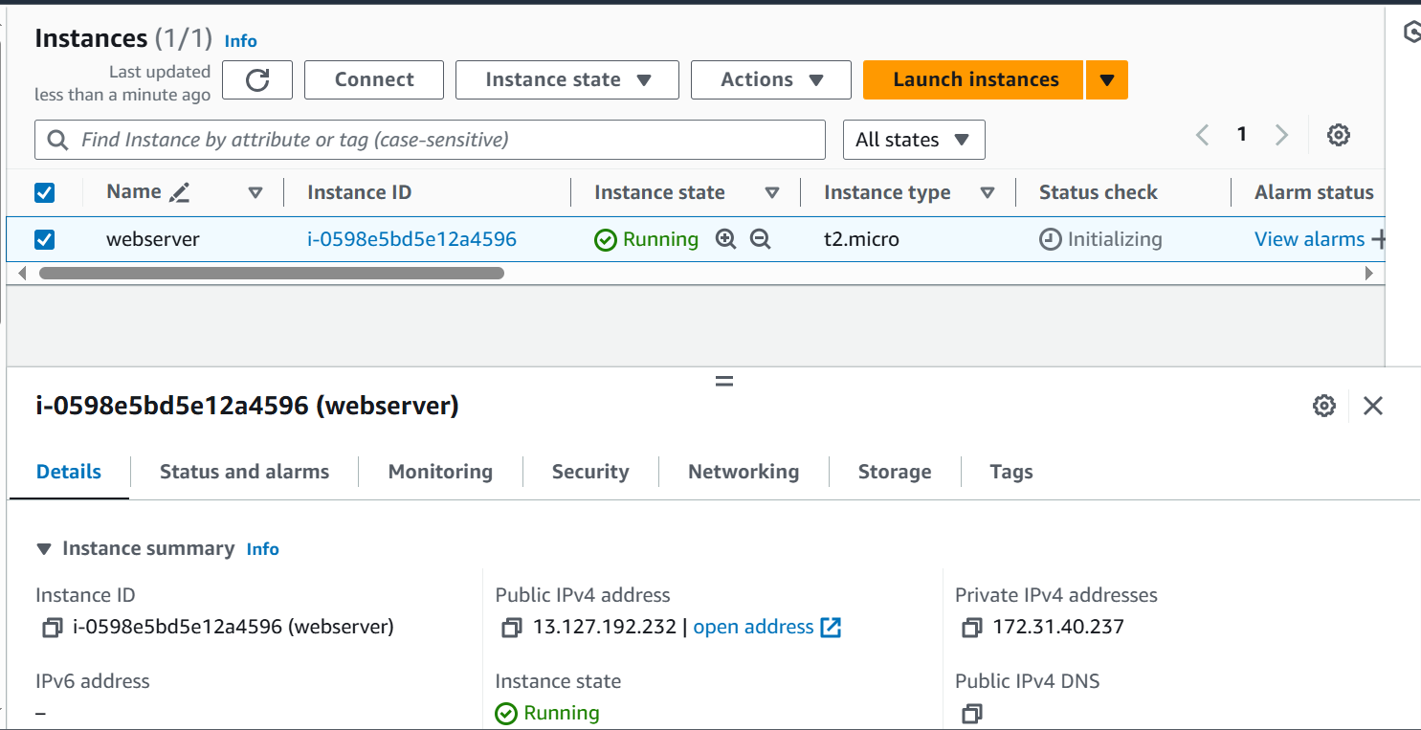

2. To access the Mobaxterm and using ssh:
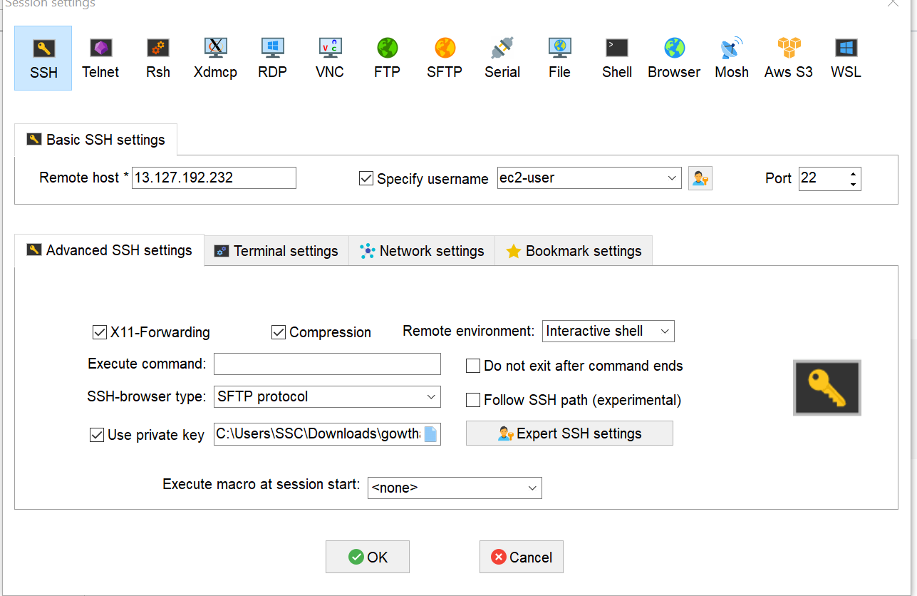

3. To check the mobaxterm output status:

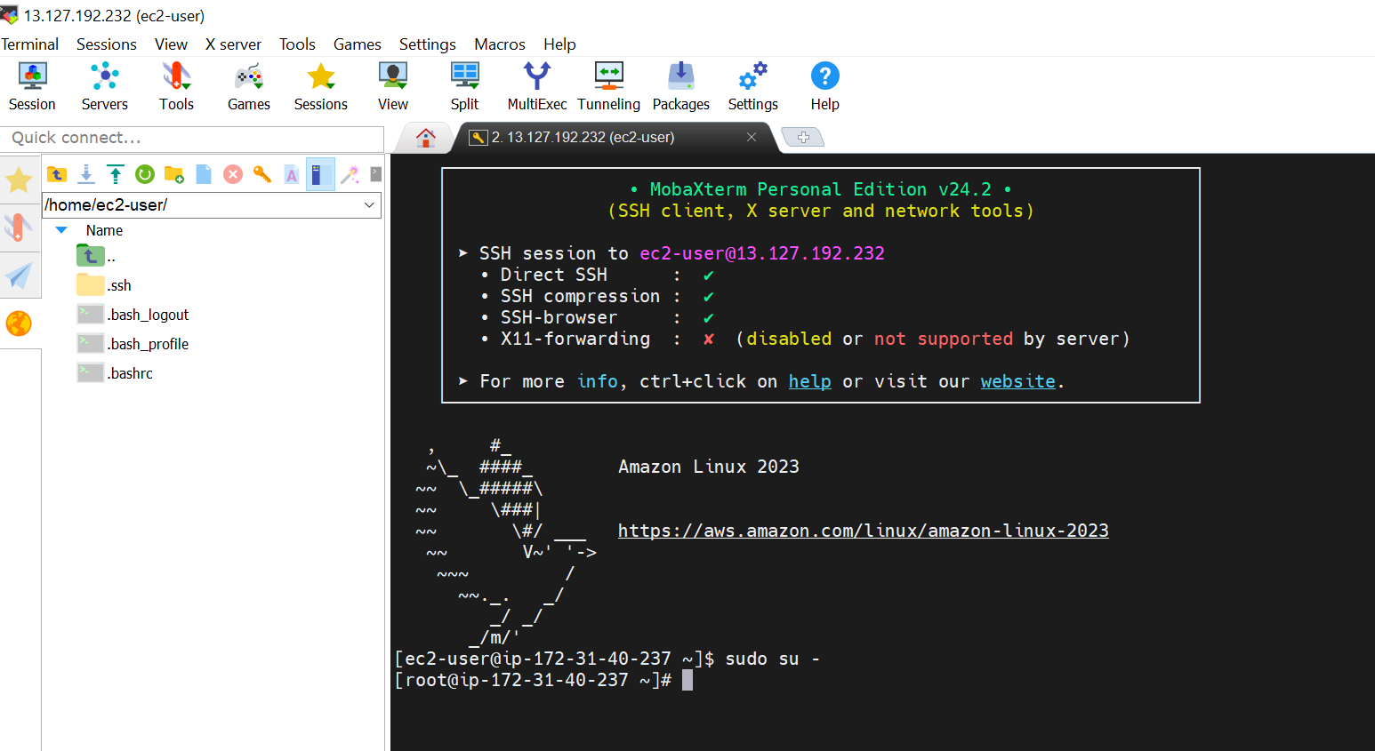

1. To access the putty and using puttygen:

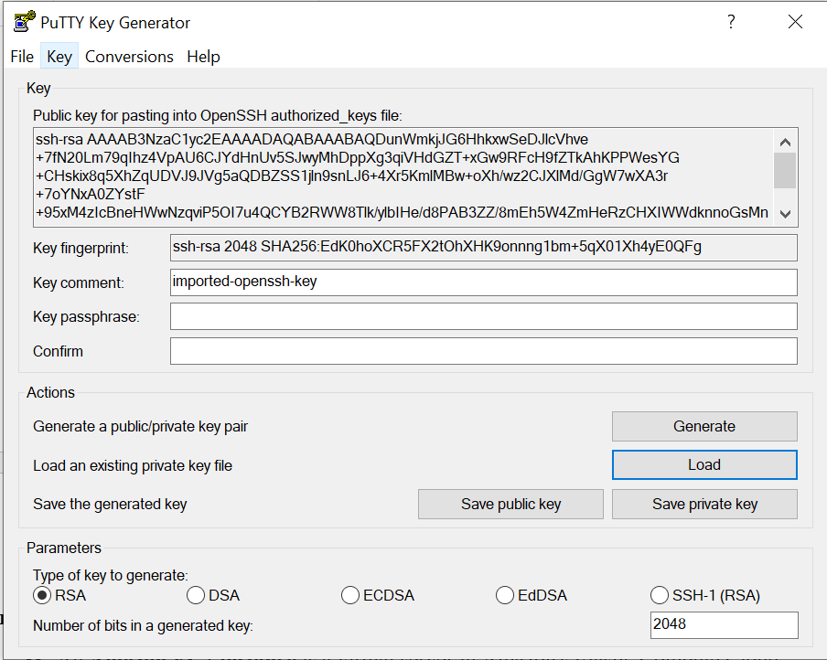

2. To enter the public ip and to using putty:

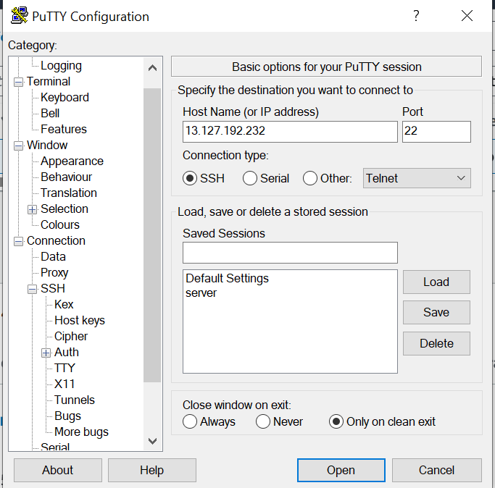
3. To click the ssh and Auth and credentials also click it and to click the ppkfile1:

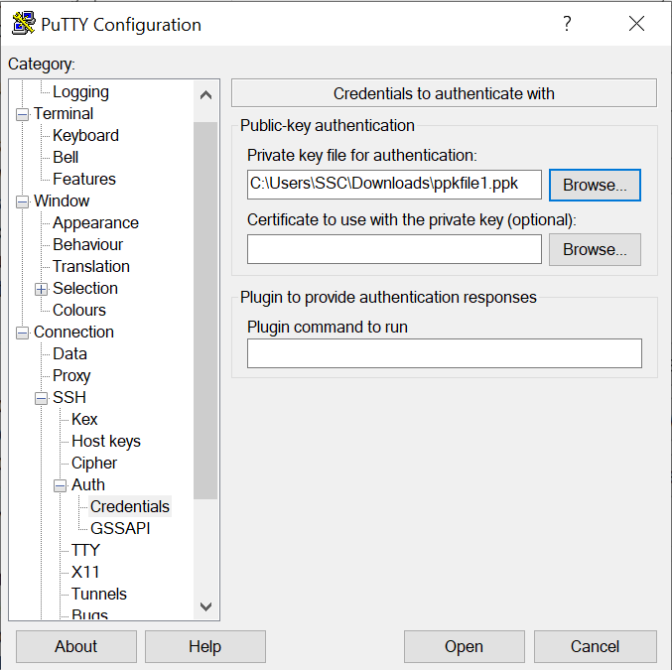
4. To seeing the ssh putty output:

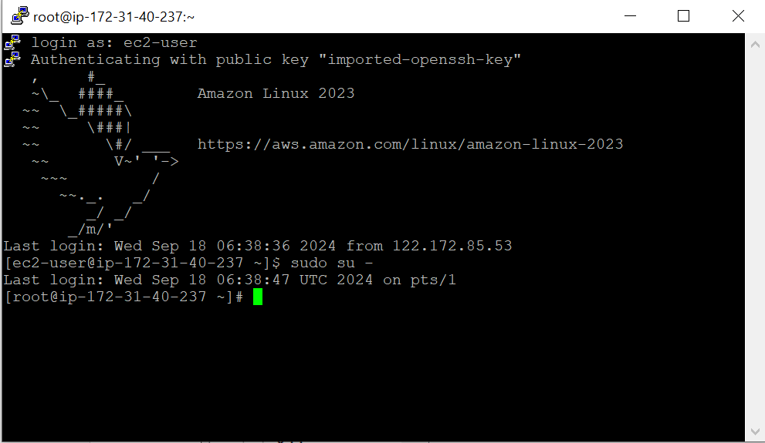

Flow chart:

How to working in Public IP and Private IP:

